**Question 1:**

Write a program to print numbers from 1 to 10.

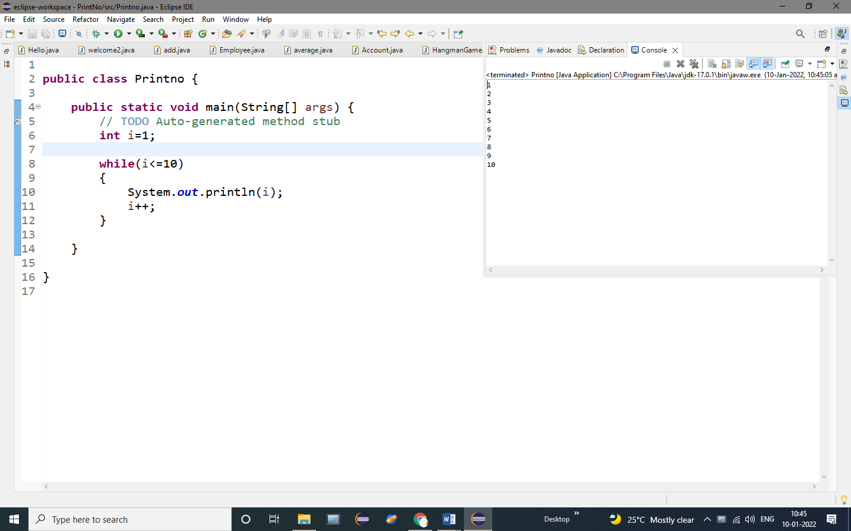

**OUTPUT:**

1

2

3

4

5

6

7

8

9

10

.

**Question 2**

Write a program to calculate the sum of first 10 natural number

PROGRAM:

**public** **class** SumofNaturalno

{

**public** **static** **void** main(String[] args)

{

// **TODO** Auto-generated method stub

**int** i,num=5,sum=0;//assign the values

**for**(i=1;i<=num;i++)

{

sum=sum+i;

}

System.***out***.println("Sum of natural Numbers is=” + is=" +sum);//print the sum value

}

}

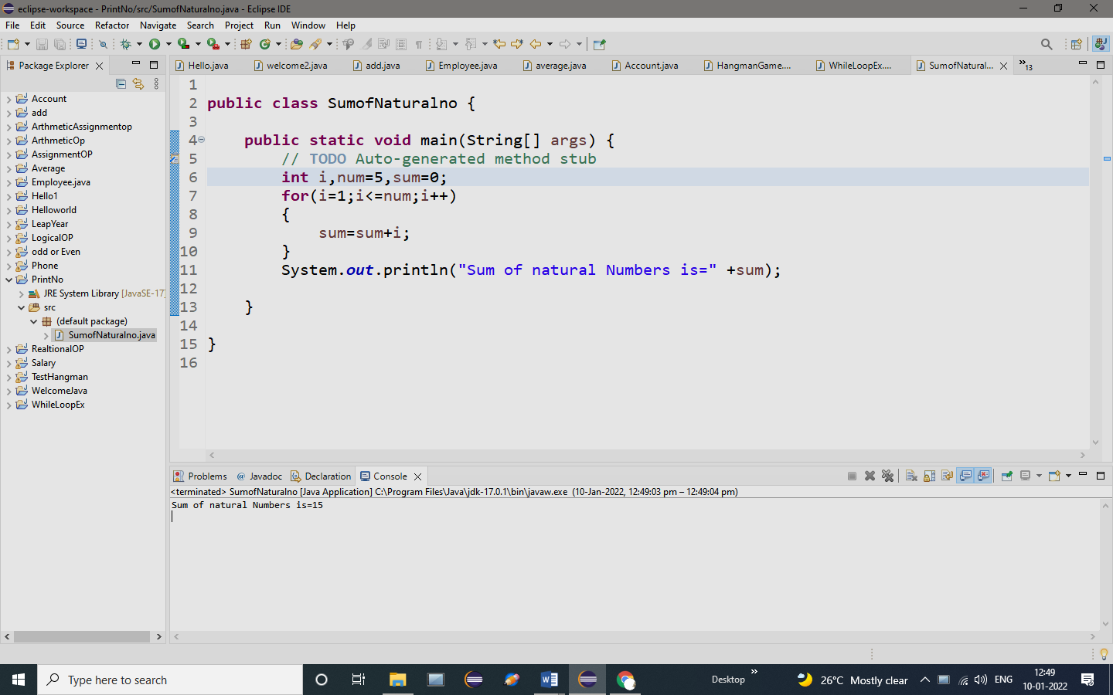

**OUTPUT:**

Sum of natural Numbers is=15

**Question 3**

Write a program that prompts the user to input a positive integer. It should then print the multiplication table of that number.

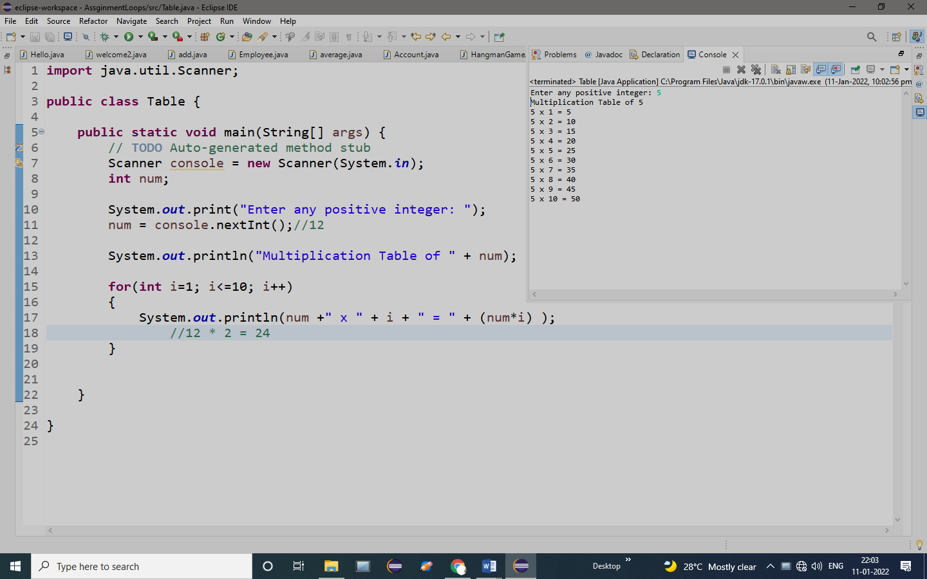

**OUTPUT:**

Enter any positive integer: 5

Multiplication Table of 5

5 x 1 = 5

5 x 2 = 10

5 x 3 = 15

5 x 4 = 20

5 x 5 = 25

5 x 6 = 30

5 x 7 = 35

5 x 8 = 40

5 x 9 = 45

5 x 10 = 50

**Question 4**

Write a program to find the factorial value of any number entered through the keyboard.

Program:

**import** java.util.Scanner;

**public** **class** FactorialDemo {

**public** **static** **void** main(String[] args) {

// **TODO** Auto-generated method stub

Scanner console = **new** Scanner(System.***in***);

**int** num; // To hold number

**int** fact = 1; // To hold factorial

System.***out***.print("Enter any positive integer: ");//user give the input

num = console.nextInt();//4

**for**(**int** i=1; i<=num; i++)//4

{

fact *= i;//fact=fact*I;//1=1*2=2=2*3=6=6*4=24

}

System.***out***.println("Factorial: "+ fact);//print the factorial value

}

}

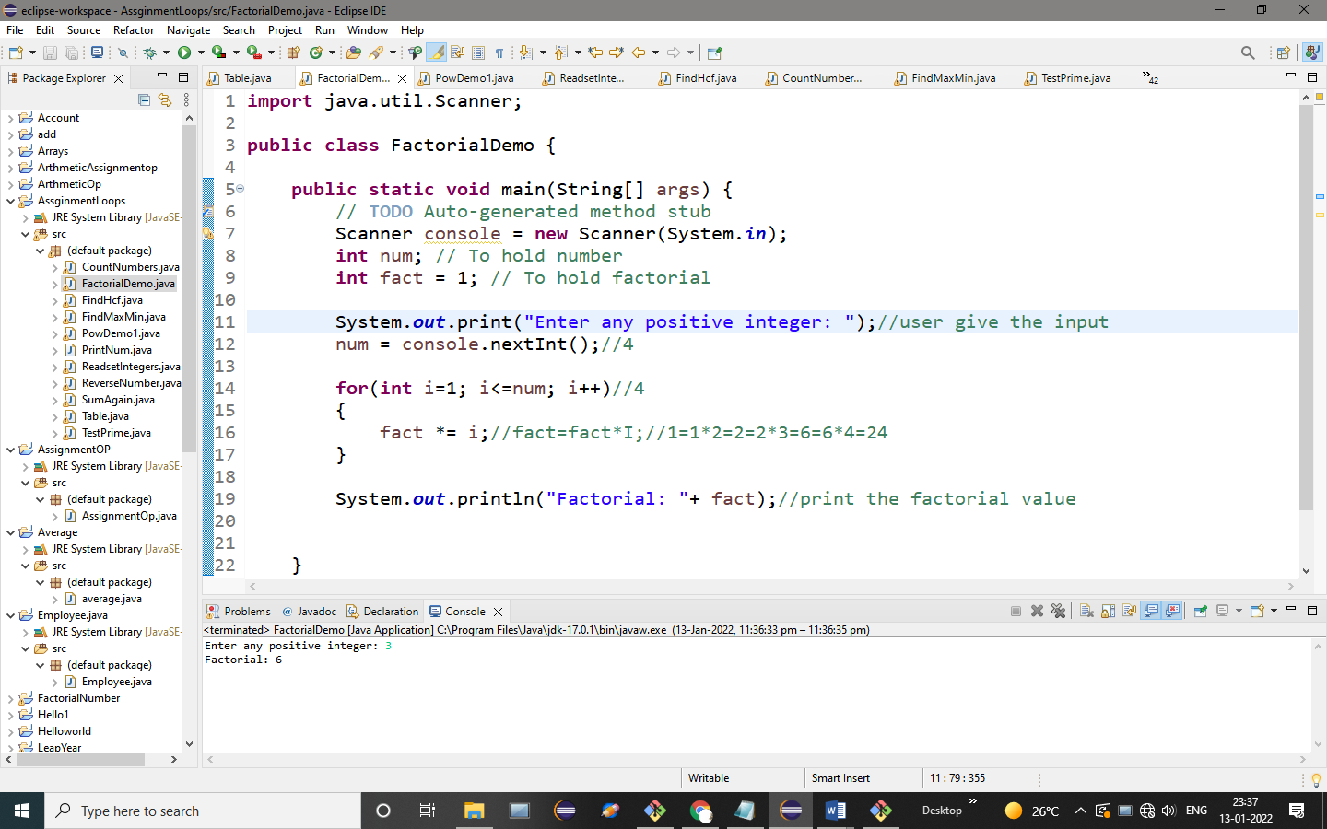

**OUTPUT:**

Enter any positive integer: 3

Factorial: 6

**Question 5**

Two numbers are entered through the keyboard. Write a program to find the value of one number raised to the power of another. (Do not use Java built-in method)

PROGRAM:

**import** java.util.Scanner;

**public** **class** PowDemo1 {

**public** **static** **void** main(String[] args) {

// **TODO** Auto-generated method stub

Scanner console = **new** Scanner(System.***in***);

**int** base;

**int** power;

**int** result = 1;

System.***out***.print("Enter the base number ");//use give the value to the base number

base = console.nextInt();//2

System.***out***.print("Enter the power ");//user give the value to the power number

power = console.nextInt();//4

**for**(**int** i = 1; i <= power; i++)//5<=4

{

result *= base;//8=2*8==16//find the base

}

System.***out***.println("Result: "+ result);//16//print the result of the base & pow number

}

}

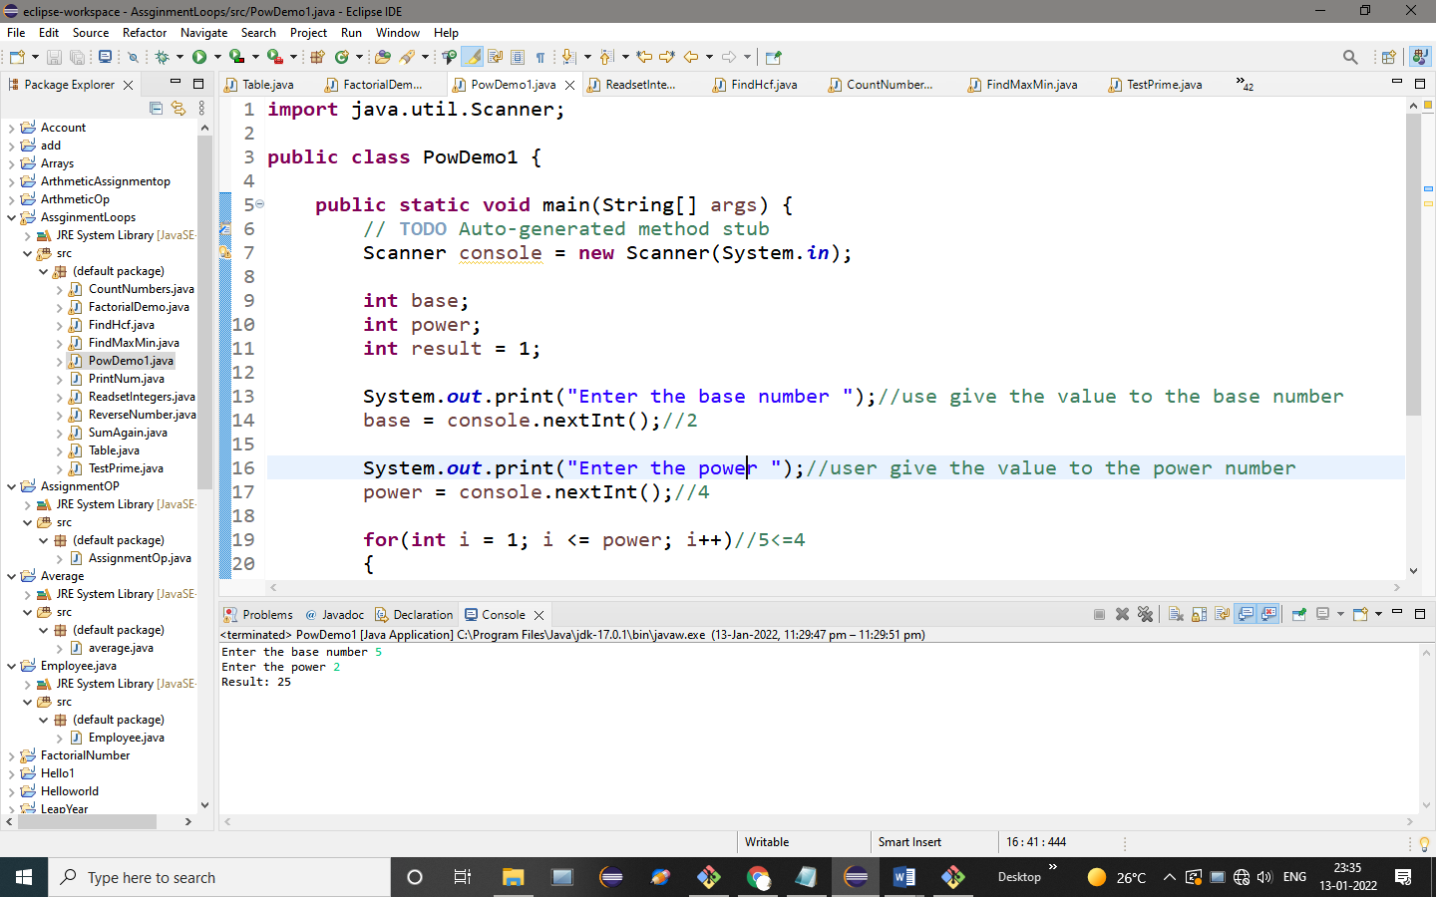

**OUTPUT:**

Enter the base number 5

Enter the power 2

Result: 25

**Question 6**

Write a program that prompts the user to input an integer and then outputs the number with the digits reversed. For example, if the input is 12345, the output should be 54321.

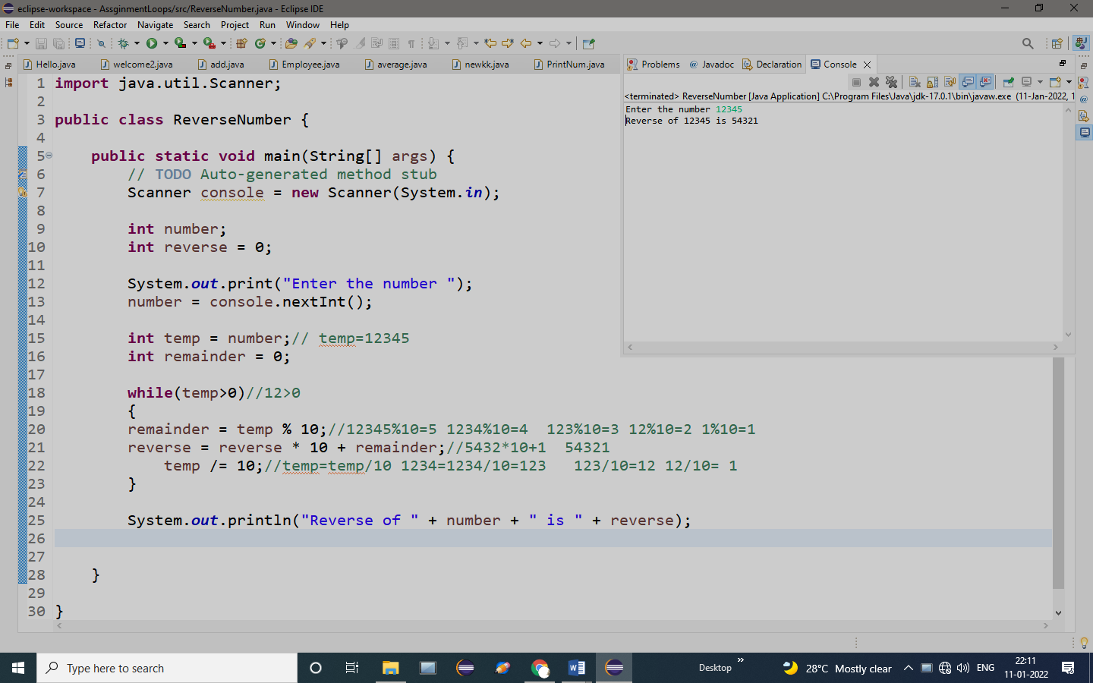

OUTPUT:

Enter the number 12345

Reverse of 12345 is 54321

**Question 7**

Write a program that reads a set of integers, and then prints the sum of the even and odd integers.

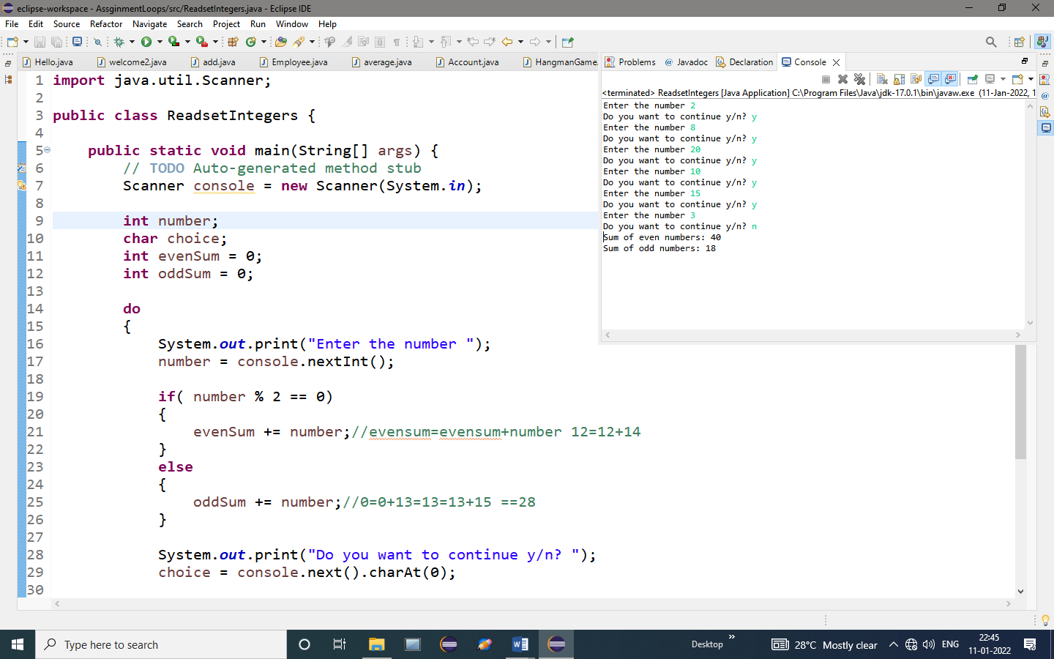

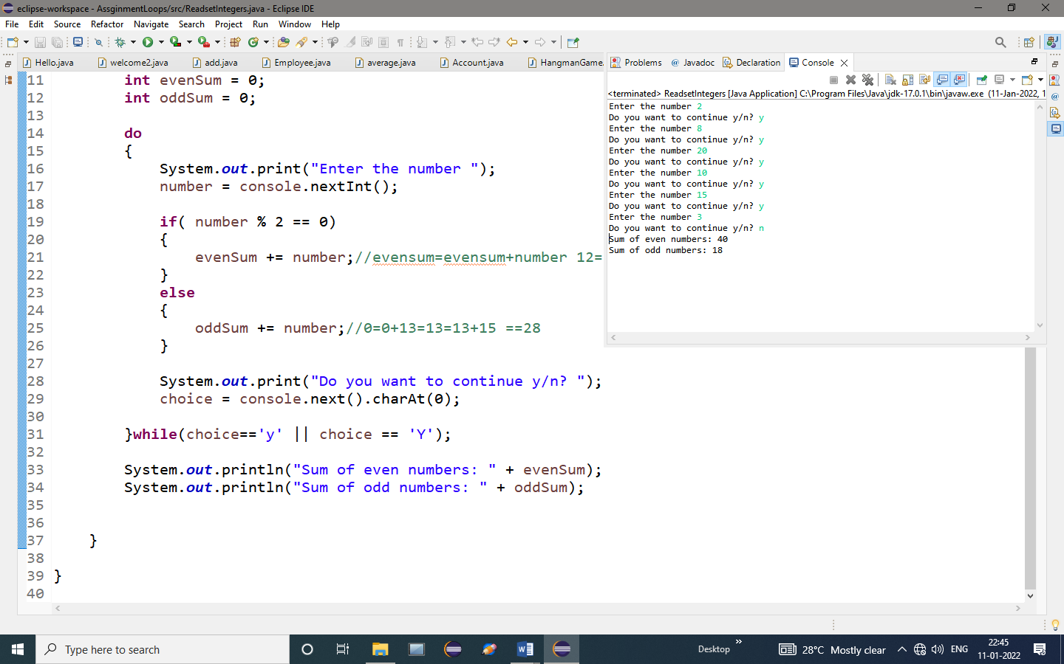

**OUTPUT:**

Enter the number 2

Do you want to continue y/n? y

Enter the number 8

Do you want to continue y/n? y

Enter the number 20

Do you want to continue y/n? y

Enter the number 10

Do you want to continue y/n? y

Enter the number 15

Do you want to continue y/n? y

Enter the number 3

Do you want to continue y/n? n

Sum of even numbers: 40

Sum of odd numbers: 18

**Question 8**

Write a program that prompts the user to input a positive integer. It should then output a message indicating whether the number is a prime number.

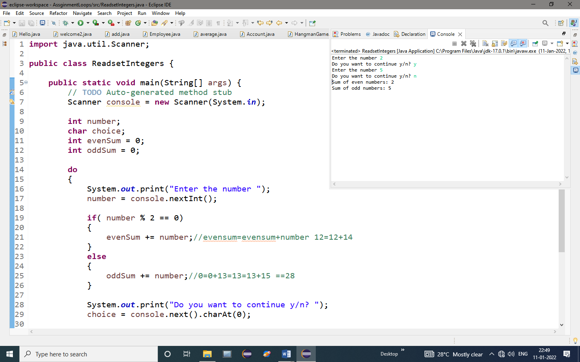

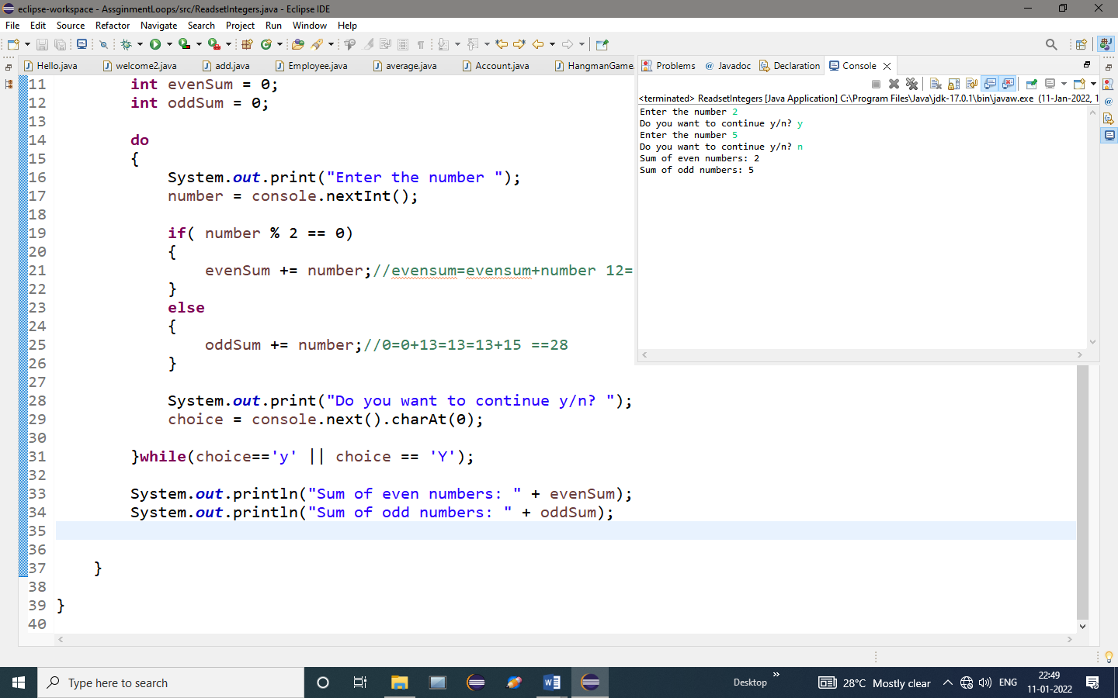

**OUTPUT:**

Enter the number 2

Do you want to continue y/n? y

Enter the number 5

Do you want to continue y/n? n

Sum of even numbers: 2

Sum of odd numbers: 5

**Question 9**

Write a program to calculate HCF of Two given number

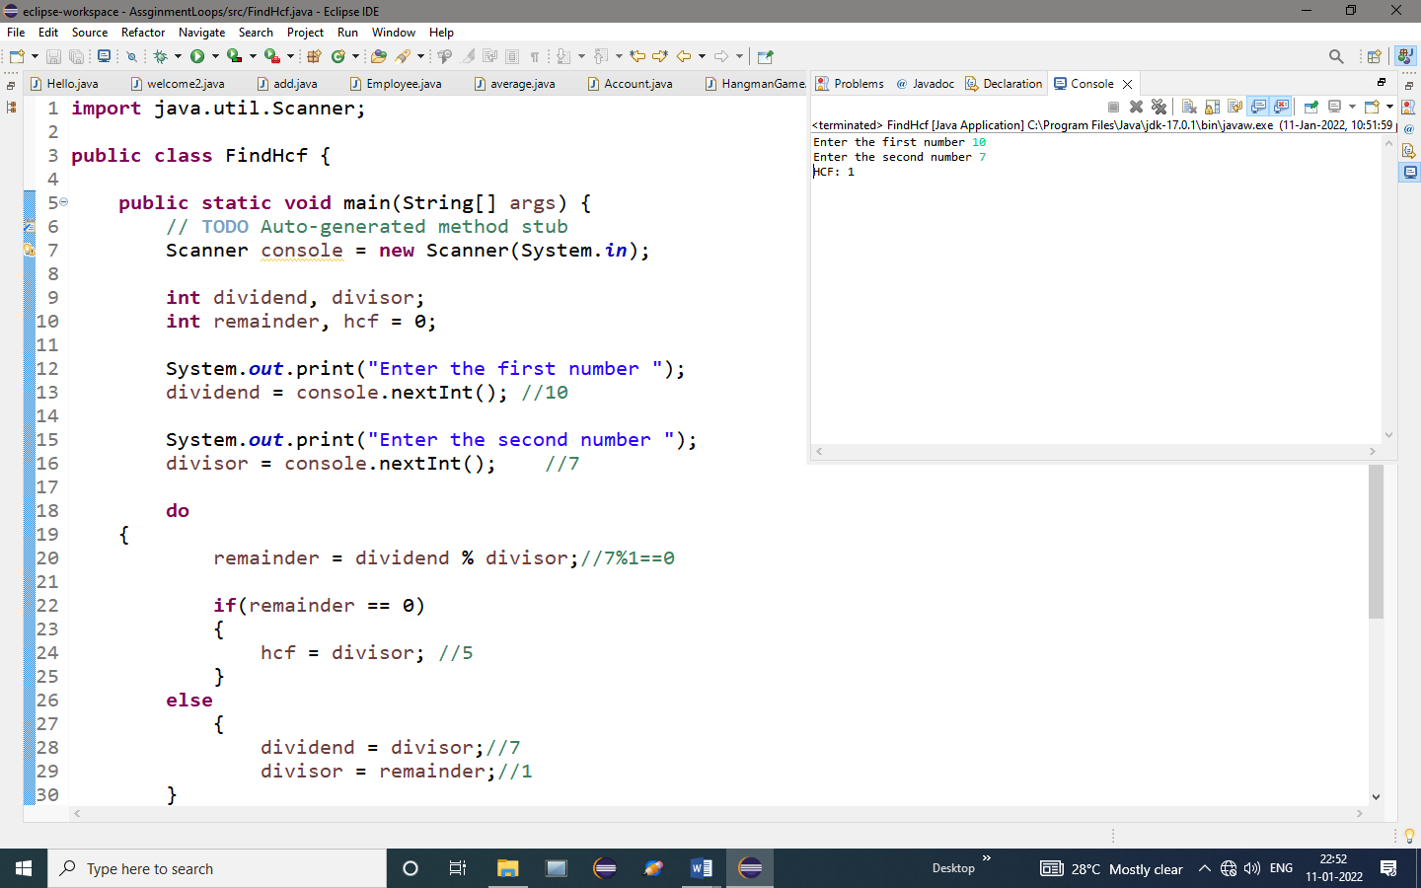

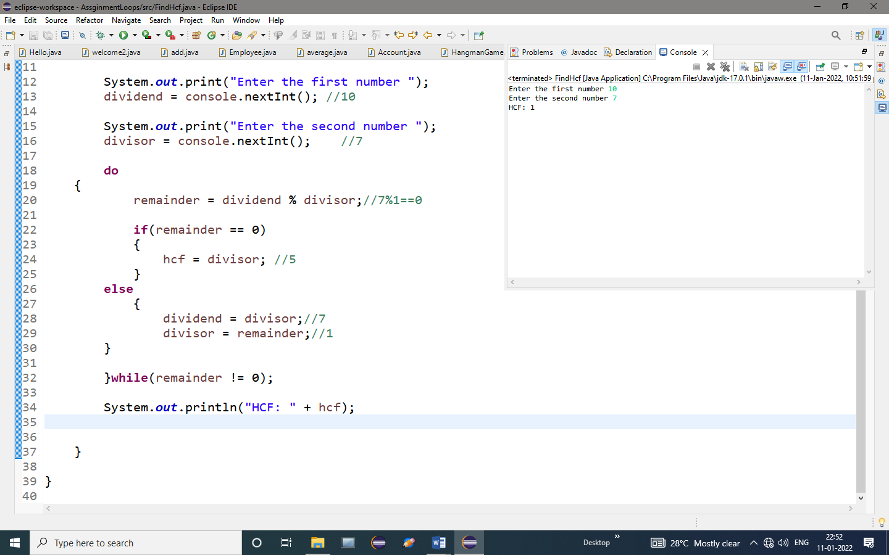

**OUTPUT:**

Enter the first number 10

Enter the second number 7

HCF: 1

**Question 10**

Write a do-while loop that asks the user to enter two numbers. The numbers should be added and the sum displayed. The loop should ask the user whether he or she wishes to perform the operation again. If so, the loop should repeat; otherwise it should terminate.

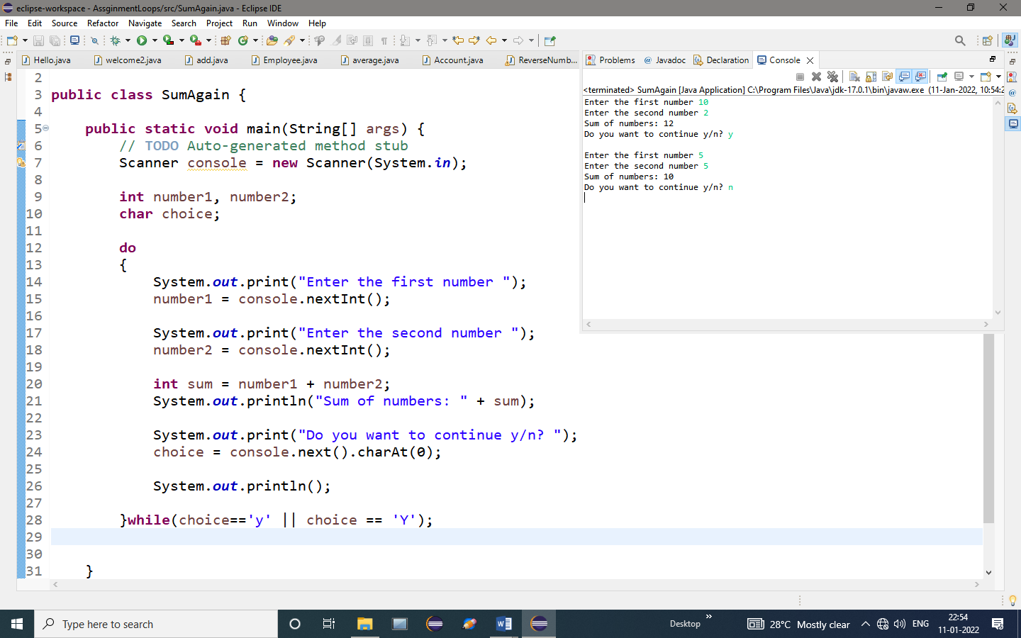

**OUTPUT:**

Enter the first number 10

Enter the second number 2

Sum of numbers: 12

Do you want to continue y/n? y

Enter the first number 5

Enter the second number 5

Sum of numbers: 10

Do you want to continue y/n? n

**Question 11**

Write a program to enter the numbers till the user wants and at the end it should display the count of positive, negative and zeros entered.

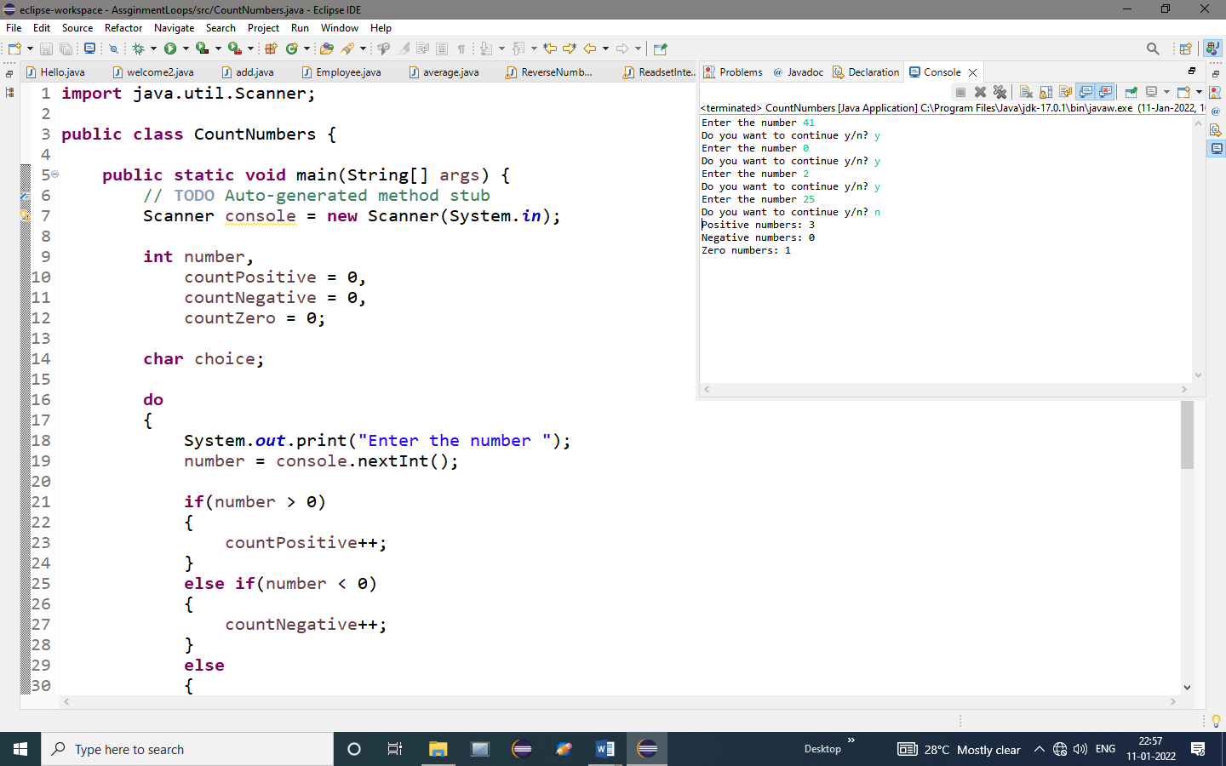

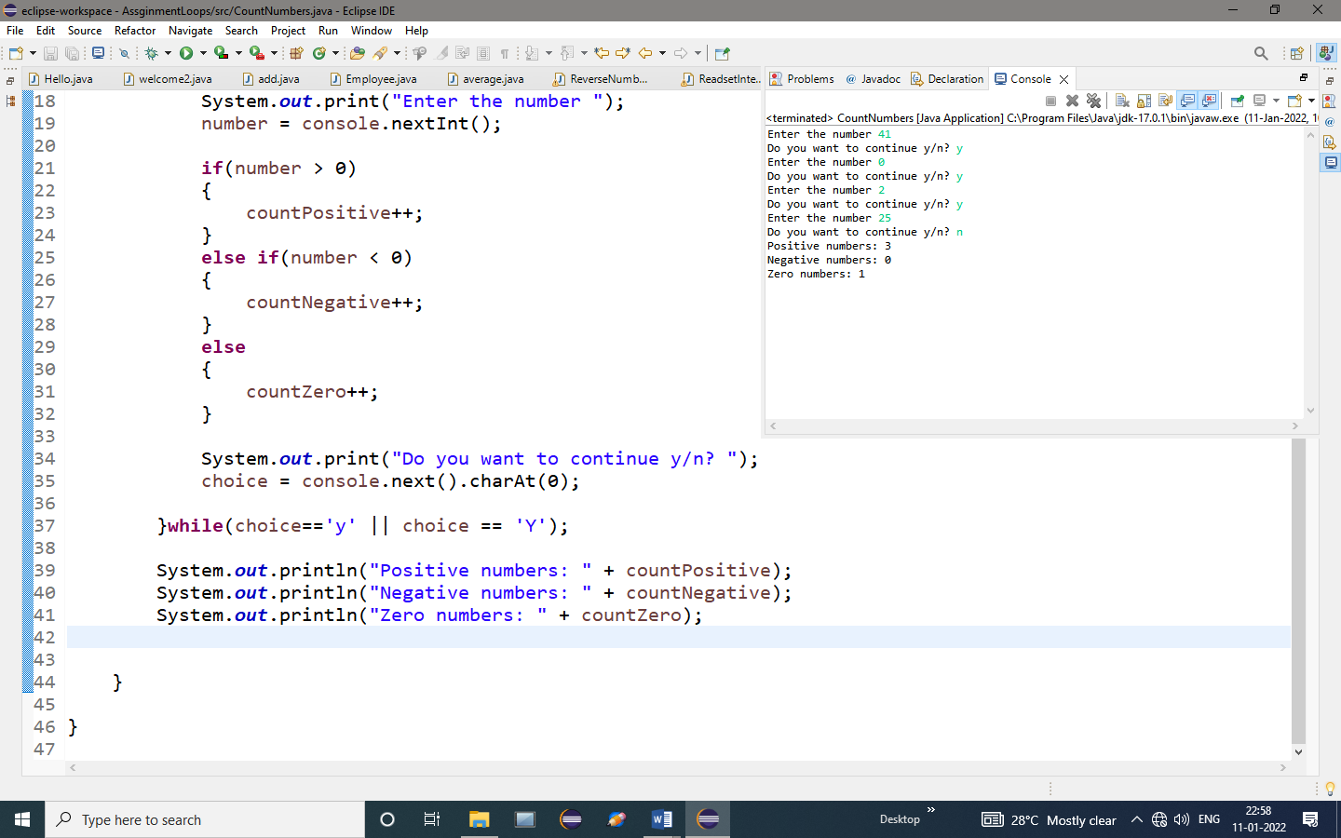

**OUTPUT:**

Enter the number 41

Do you want to continue y/n? y

Enter the number 0

Do you want to continue y/n? y

Enter the number 2

Do you want to continue y/n? y

Enter the number 25

Do you want to continue y/n? n

Positive numbers: 3

Negative numbers: 0

Zero numbers: 1

**Question 12**

Write a program to enter the numbers till the user wants and at the end the program should display the largest and smallest numbers entered.

PROGRAM:

**import** java.util.Scanner;

**public** **class** FindMaxMin {

**public** **static** **void** main(String[] args) {

// **TODO** Auto-generated method stub

Scanner console = **new** Scanner(System.***in***);

**int** number;

**int** max = Integer.***MIN_VALUE***; // Intialize max with minimum value

**int** min = Integer.***MAX_VALUE***; // Intialize min with maximum value

**char** choice;

**do**

{

System.***out***.print("Enter the number ");

number = console.nextInt();//2

**if**(number > max)//3>12

{

max = number;//12

}

**if**(number < min)//3<0

{

min = number;

}

System.***out***.print("Do you want to continue y/n? ");

choice = console.next().charAt(0);

}**while**(choice=='y' || choice == 'Y');

System.***out***.println("Largest number: " + max);

System.***out***.println("Smallest number: " + min);

}

}

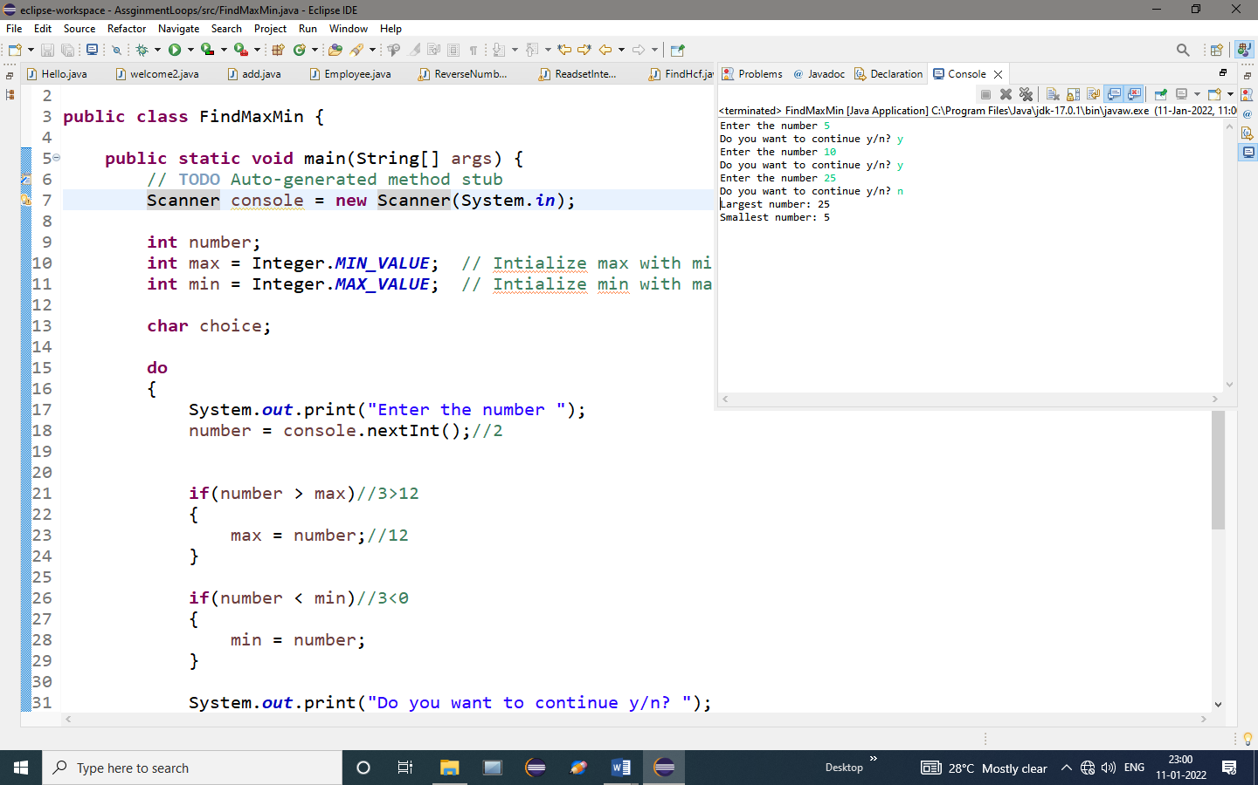

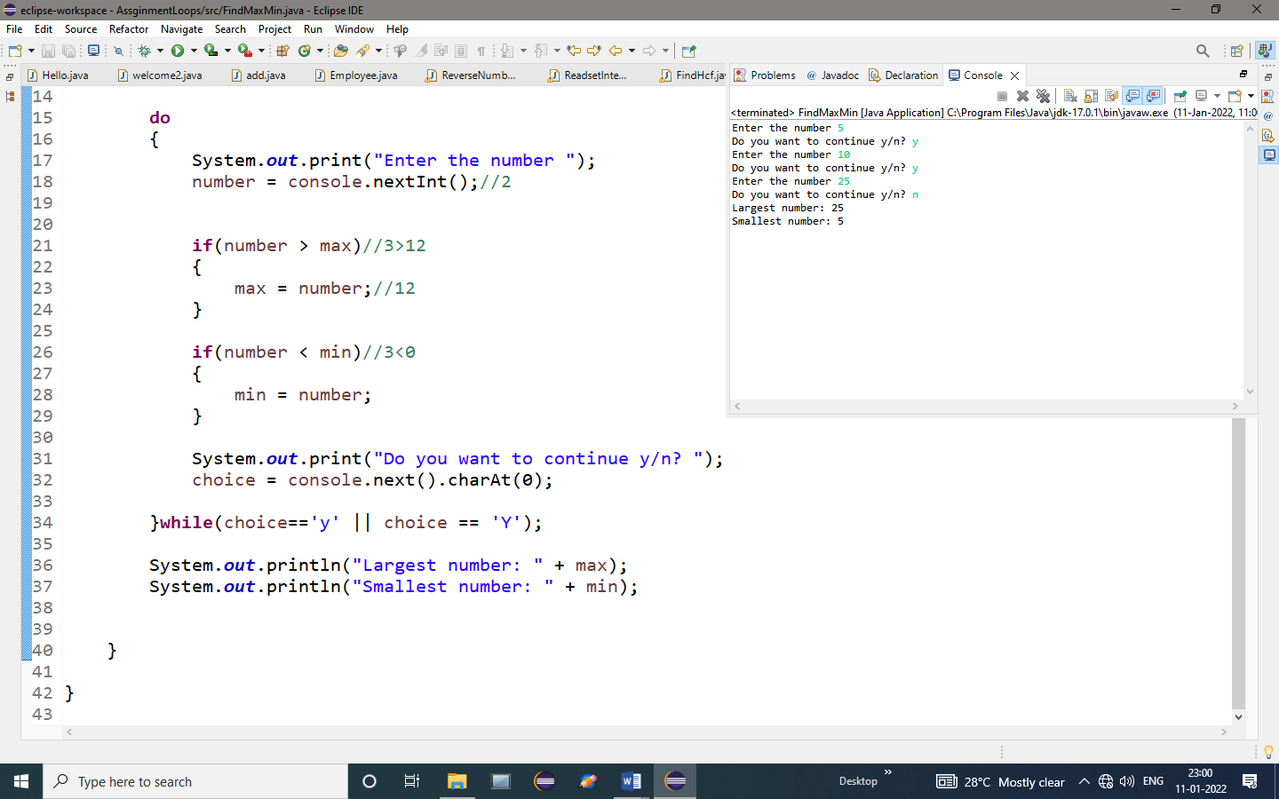

**OUTPUT:**

Enter the number 5

Do you want to continue y/n? y

Enter the number 10

Do you want to continue y/n? y

Enter the number 25

Do you want to continue y/n? n

Largest number: 25

Smallest number: 5